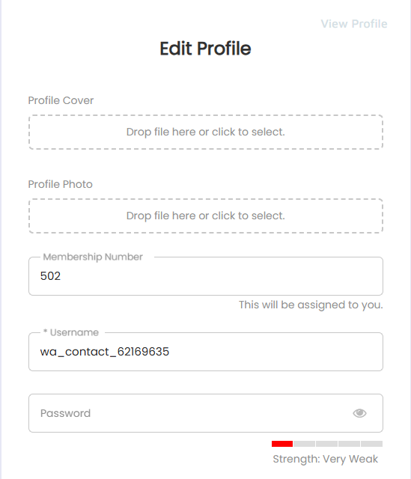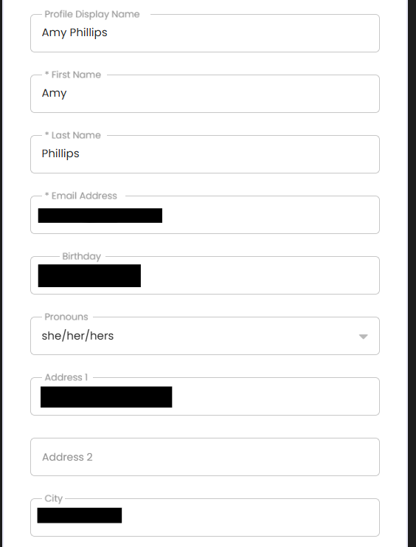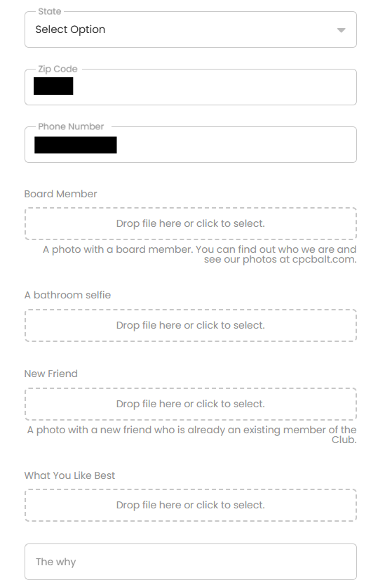
The system assigned this to you or you picked it out, either way you can’t change it now.
You can change password here
Change your profile picture
If you want a background you can upload here
Click here to view your profile
DO NOT CHANGE OR TOUCH THIS
What name do you want on your profile?
City (not shown on profile)

Address (not shown on profile)

Birthdate (not shown on profile)

Email (not shown on profile)

Last Name (not shown on profile)

First Name (not shown on profile)
Please fill out your address so we can send our Holiday Postcard to you!
Apt Number or other info
Pronouns
Tell us why you want to be a member (not shown on profile)

Hit the submit button and your profile is updated!!
Upload a photo of what you like best
Upload a phot of your new friend
Upload a bathroom selfie
Upload picture with board member
Phone (not shown on profile)

Zip Code (not shown on profile)

State (not shown on profile)

The rest if for probationary members, but you can fill it out too if you want to

